**Wigton Motor Club Ltd**

**Formed in 1923**

**Cumbria Classic & Motorsport Show**

**Supporting Hospice at Home (Carlisle and North Lakeland)**

**and Every Life Matters**

**Sunday, August 17th**

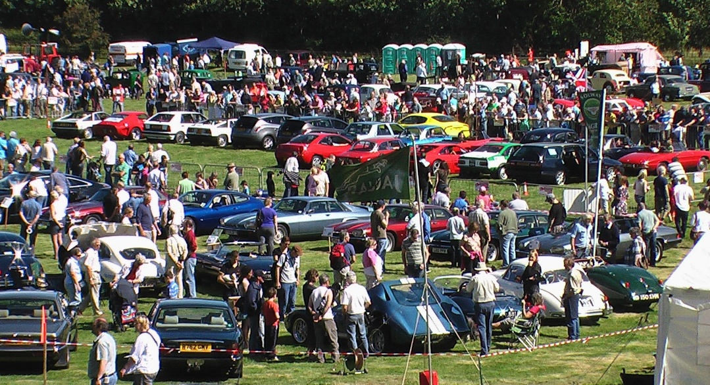

**at**

**Dalemain**

**Near Ullswater**

**On the A592**

**Vehicle Entry Form**

**Limited to 800 vehicles**

**WIGTON MOTOR CLUB LTD**

**Cumbria Classic Weekend 2025**

Welcome to the thirty fourth **Cumbria Classic Weekend** which this year takes place over the weekend of August 16/17th We are repeating our successful format with a package of two events, which we hope will encourage you to stay in the Lake District.

**The Rose and Thistle Tour** takes place on Saturday and visits some of the most interesting roads in England and Scotland. Sunday sees the **Cumbria Classic Car Show** staged in the spectacular setting of Dalemain by Ullswater

As well as the usual club stands, autojumble, and hundreds of cars we will have arena action, autotests, motorsport display, a trade area, craft stalls, entertainment and toy and produce stalls.

This year we have two featured classes: Italian cars and Rally cars.

The £5 entry fee for individual entries will admit two people to the show and a superb, limited edition attendance award, to a total worth of £25!! **Wigton MC members will be able to enter their car free of charge as long as they quote their membership number on the entry form.**

Club entries are made on the Club entry form which is on the website. [www.wigtonmc.co.uk](http://www.wigtonmc.co.uk)

**The closing date for entries is firm and no entries will be accepted on the show day under any circumstances**. **This year we are capping the total number of entries at 800, split equally between club displays and individual entries.**

**Camping:** Due to the demand from entrants who wish to camp we can offer pre booked camping permits for £20 per unit. This price is set by the estate. You can camp only on the **Saturday night**. Camping must be paid with your entry fee. Camping is only permitted for vehicle entrants, not spectators.

**We look forward to seeing you in August but do please remember that all the events fill up very quickly!**

**Contacts:**

Cumbria Classic Show car entries John Graham DaleEntries24@outlook.com

Autojumble and trade stands David Agnew [davidwagnew@aol.com](mailto:davidwagnew@aol.com)

Club Displays John Holliday [johnholl403@gmail.com](mailto:johnholl403@gmail.com)

Rose & Thistle Challenge Ron Palmer [ronpalmer777@hotmail.com](mailto:ronpalmer777@hotmail.com)

|  |
| --- |
|  |

General Graeme Forrester [gtfmg@yahoo.co.uk](mailto:gtfmg@yahoo.co.uk)

“No Shows” In common with all other shows there are too many people who enter and then fail to turn up leaving gaps on the field. We appreciate that there are reasons for being unable to come, such as illness or mechanical issues, but it is courteous to phone the entries secretary to let them know. Failure to turn up , or not informing us in advance, could lead to your entry being refused in future years.

Unfortunately, we are not allowing 4x4 vehicles on the autotest.

At the conclusion of the show you are asked to drive considerately as you leave. Anyone seen driving over enthusiastically will be banned from future events.

***Wigton Motor Club is a not for profit organisation run entirely by volunteers. Any surplus from the Show goes to enhancing the Club’s activities and to support our chosen charities. Full details of the Club and our officials can be found on our website.*** [***www.wigtonmc.co.uk***](http://www.wigtonmc.co.uk)

# Wigton Motor Club

# CUMBRIA CLASSIC SHOW

**Sunday, August 17th**

## INTRODUCTION

We have pleasure in inviting you to display your car at Cumbria's biggest display of classic and modified modern cars. Every exhibitor will receive a **superb attendance award** and receive **free admission** for **two** occupants and their car.

**Classes:**

|  |  |  |  |  |  |  |
| --- | --- | --- | --- | --- | --- | --- |
| A | All pre-1950 cars including vintage and veteran | | | | | |
| B | Saloon Cars 1951 - 1960 | | | |  |  |
| C | Sports & GT Cars 1951 - 1960 | | | |  |  |
| D | Sports & GT Cars 1961 - 1970 | | | |  |  |
| E | Saloon cars 1961 -1970 | | |  |  |  |
| F | Open Sports Cars 1971 - 1980 | | | |  |  |
| G | GT (Closed) Cars 1971-1980 | | | |  |  |
| H | Saloon Cars 1971 - 1980 | | | |  |  |
| I | Saloon cars 1981 to 1990 | | | |  |  |
| J | Saloon cars - 1991 to 2000 | | | |  |  |
| K | Sports and GT Cars - 1981 to 2000 |  |  |  |  |  |
| L | Sports & GT Post 2000 | | | |  |  |
| M | Saloon cars - Post 2000 | | | |  |  |
| N | Military, 4WD, Light Commercials, tractors and PSVs | | | | | |
| O | Kit Cars & Classic Replicas | | | |  |  |
| P | Motor Bikes | |  |  |  |  |
| Q | Super Cars | |  |  |  |  |
| **R** | **Rally and Comp cars** | | |  |  |  |
| S | Performance & Modified cars | |  |  |  |  |
| Y | Young Guns (owners under 25) | |  |  |  |  |
| **ITAL** | **Italian cars of any age** | | |  |  |  |

The organisers reserve the right to re classify or reject any entry.

**Entries:**

The Entries Secretary is John Graham, 86, Moor Park Ave, Belle Vue, Carlisle, CA2 7LY. Telephone 01228 534483. Email: daleentries24@outlook.com; The maximum number of **individual** entries is 400. Entries will be accepted in order of receipt.

**Timetable:**

July 20th Entries close. No entries will be accepted after this date.

August 10th Final instructions posted to exhibitors.

August 17th 0900 -1000 Cars arrive, and park as directed.

1030 Last admission time for exhibitors

1100 Show opens. Judging starts.

**Exhibitors** are asked not to leave prior to 4pm without prior arrangement with the organisers. The attendance awards will be given out from 4pm

**Concours Awards:**

Awards will be presented to the first three in each class, subject to the number of entries. Larger classes may have more awards. Classes may be amalgamated or split at the organiser’s discretion. Award winners will receive a unique perpetual award and certificate. The self-judging system will be used. Cars on club stands **are not eligible** for class awards. However there are awards for the best club stands. These will also be self-judging.

Admin only

**Wigton Motor Club**

**Cumbria Classic Show 2025** Class Number

**Vehicle Entry Form**

|  |  |  |
| --- | --- | --- |
| **Make:** | **Model:** | |
| **Year:** | **Class:** |  |
| **Reg. No.** | **Colour:** | |

|  |  |
| --- | --- |
| **Owner:** | |
| **Address:** | |
|  | |
|  | |
|  | |
| **Post Code:** | **Phone:** |
| **Email:** | |

**Entry fees**

|  |  |
| --- | --- |
| **Entry fee per vehicle (£5.00)** | **£** |
| **Wigton MC member (free)** | 2025 membership number: |
| **Camping permit £20 per unit per night** | **£** |
| **Total** | **£ :00** |

**Only one entry per form please. Photocopies are accepted.**

Please return this form to John Graham, 86, Moor Park Ave, Belle Vue, Carlisle, CA2 7LY, or by emailing to: DaleEntries24@outlook.com

by July 20th , enclosing a £5 note which saves us paying bank charges, or by BACS with your name as the reference. Wigton Motor Club, HSBC Sort Code 40.34.18 Account 44669770 . We are not accepting cheques due to the extra fees charged by banks.

**Entries will be accepted in order of receipt to a maximum of 400.**