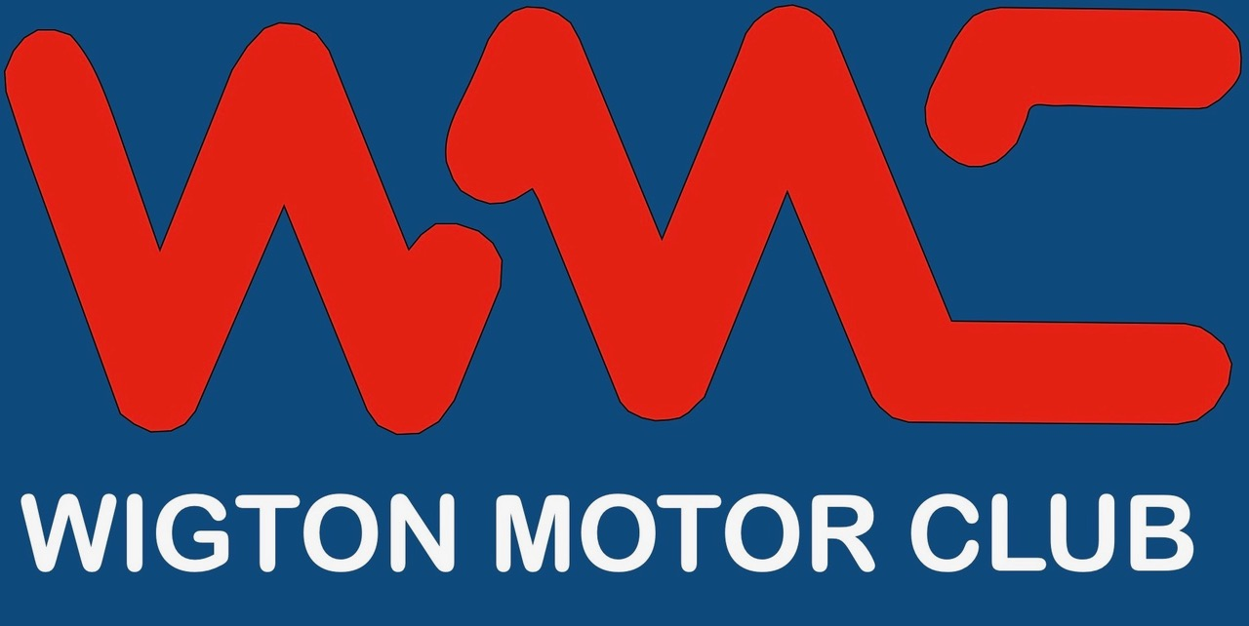

Summer Autosolo

Sunday 28th July 2024 Maryport

Supplementary Regulations

1/ Announcement Wigton Motor Club will promote Clubsport Autosolo on Sunday 28th July 2024 at Maryport Business Centre, Main Road, Maryport CA15 8NG, south of the West Coast Karting building..

2/ Jurisdiction The meeting will be held under the General Regulations of Motorsport UK (incorporating the provisions of the International Sporting Code of the FIA), these Supplementary Regulations and any written instructions that the organising club may issue for the event.
Motorsport UK permit number - TBA

3/ Eligibility Competitors must be a member of Wigton Motor Club. Alternatively, Spadeadam MC, West Cumbria MSC, Eden Valley MC, South of Scotland CC, Kirkby Lonsdale MC & Hexham & DMC are also invited to enter.

All competitors (Drivers and Navigator/Passenger) must be in possession of a Motorsport UK RS Clubman licence as a minimum. Available free from - https://www.motorsportuk.org/competitors/rs-clubman-licence/

A passenger is permitted but must be aged 12 years or over +135cm in height. Cars with no hood/hardtop fitted, passenger must be 16 years or over. The choice of having the hood erected or hardtop fitted for cabriolet/sports cars is open for the driver to decide. Seat belts must be worn and road tyres only for all vehicles.

4/ Championship The event is a qualifying round of the WMC club championships. Results will be entered into the most appropriate club championship class.

5/ Programme Will be as follows:
Arrival from 09.30
First test from 10.30
Estimated finish 15.00

6/ Classes There will be 4 classes at the event.
F) FWD H) Pre 1984
R) RWD J) Junior (under 17 years)

The minimum for a class is 3. The maximum for the event is 20 and the minimum will be 10. Should the minimum figure not be reached the organisers reserve the right to cancel the meeting.
All vehicles must be driven into the venue and be taxed, insured and have a valid MOT where appropriate. The responsibility for this lies with the entrant.

7/ Junior entries – Autosolo entries may be accepted from drivers who are 14 years or over who do not hold a full RTA licence subject to the following: The vehicle must in definition be a ‘touring car’, engine capacity must not exceed 2000cc including forced induction. A passenger must be carried who holds a full RTA licence and has Autosolo experience.

8/ Entry The entry list opens with the publication of these regulations and closes five days before the event.
Entries must be made on the attached form and emailed to the organiser. Entries will not be accepted by phone or social media or on the day. The entry fee is £25. Late entries will be accepted if there is space available with a surcharge of £5.

.
9/ Times/Penalties Timing will be to the nearest whole second. All protests must be made in accordance with the Motorsport UK yearbook, section C.
a) Failure to attempt a test 20 secs plus the fastest within the class
b) Wrong test * 20 secs plus the fastest within the class
c) Striking a cone or marker 5 secs for each occurrence
d) Failure to stop astride any line 5 secs for each occurrence including the finish line
e) Jump start 5 secs
* If the driver returns to the point of their mistake, and then completes the test correctly, there is no penalty.
In every other case the time taken will be the time recorded.

Drivers will be identified by name and/or number. Timing will be by marshals stop watch using a countdown. Timing will stop when the leading wheel of the front axle crosses the line of the stop astride/finish line. Times will be recorded on the marshals sheet, he/she will convey the time of each test to the driver.

10/ Tests There will be one large test area with changing layouts, each run at least three times with all scores being taken into account for the total time. This may vary according to competitor numbers, weather etc.
Diagrams will be made available on the day. Tests are marked with cones which may be less than 1 metre in height.

11/ Noise Specifically relating to the Maryport site – Testing will be carried out to confirm compliance of J.5.17 and J.5.18 ie. 88db at 2m distance at 4500rpm. Any entrant not able to comply will be unable to start the event.

12/ The officials will be:
Clerk of the Course: Steve Fishwick
Secretary of Meeting Steve Fishwick
Chief Marshal Eddie Parsons
Chief Timekeeper: Mary Parsons

13/ Awards There will be no awards for this event.

14/ Facilities Toilet facilities will be available on site. Please bring your own food and drink.

Acknowledgements
Landowner – Cunberland Council
Motorsport UK
All Officials and Marshals

Wigton Motor Club Ltd

Entry Form

Please complete in block capitals

Summer Autosolo Maryport 28th July 2024
Driver:
Club: WMC/Other: Membership number:
Motorsport UK licence number:
Address:
Post Code: Tel No:
Email address:
Next of Kin: Tel No:
If under 18 years, provide parent/guardian contact details below.
Name: Tel No:
Passenger (optional):
Club: WMC/Other: Membership number:
Motorsport UK licence number:
Address:
Post Code: Tel No:
Email address:
Next of Kin: Tel No:
If under 18 years, provide parent/guardian contact details below.
Name: Tel No:
Car Details
Car Make: | Class:
Model: | Capacity:
Full Entry Fee | £ 25 : 00
Late Entry Fee (less than 5 days before the event) | £ 5 : 00
Total | £

Entries must be made on this form and emailed or by WhatsApp complete to:
Steve Fishwick : fishwick38@gmail.com 07796871899

Please pay by bank transfer to –
Wigton Motor Club HSBC Account 40 46 34 Account: 11016555

