Wigton Motor Club

Cumbrian Canter

Sunday, 22nd September 2024

Regulations

and

Entry Form

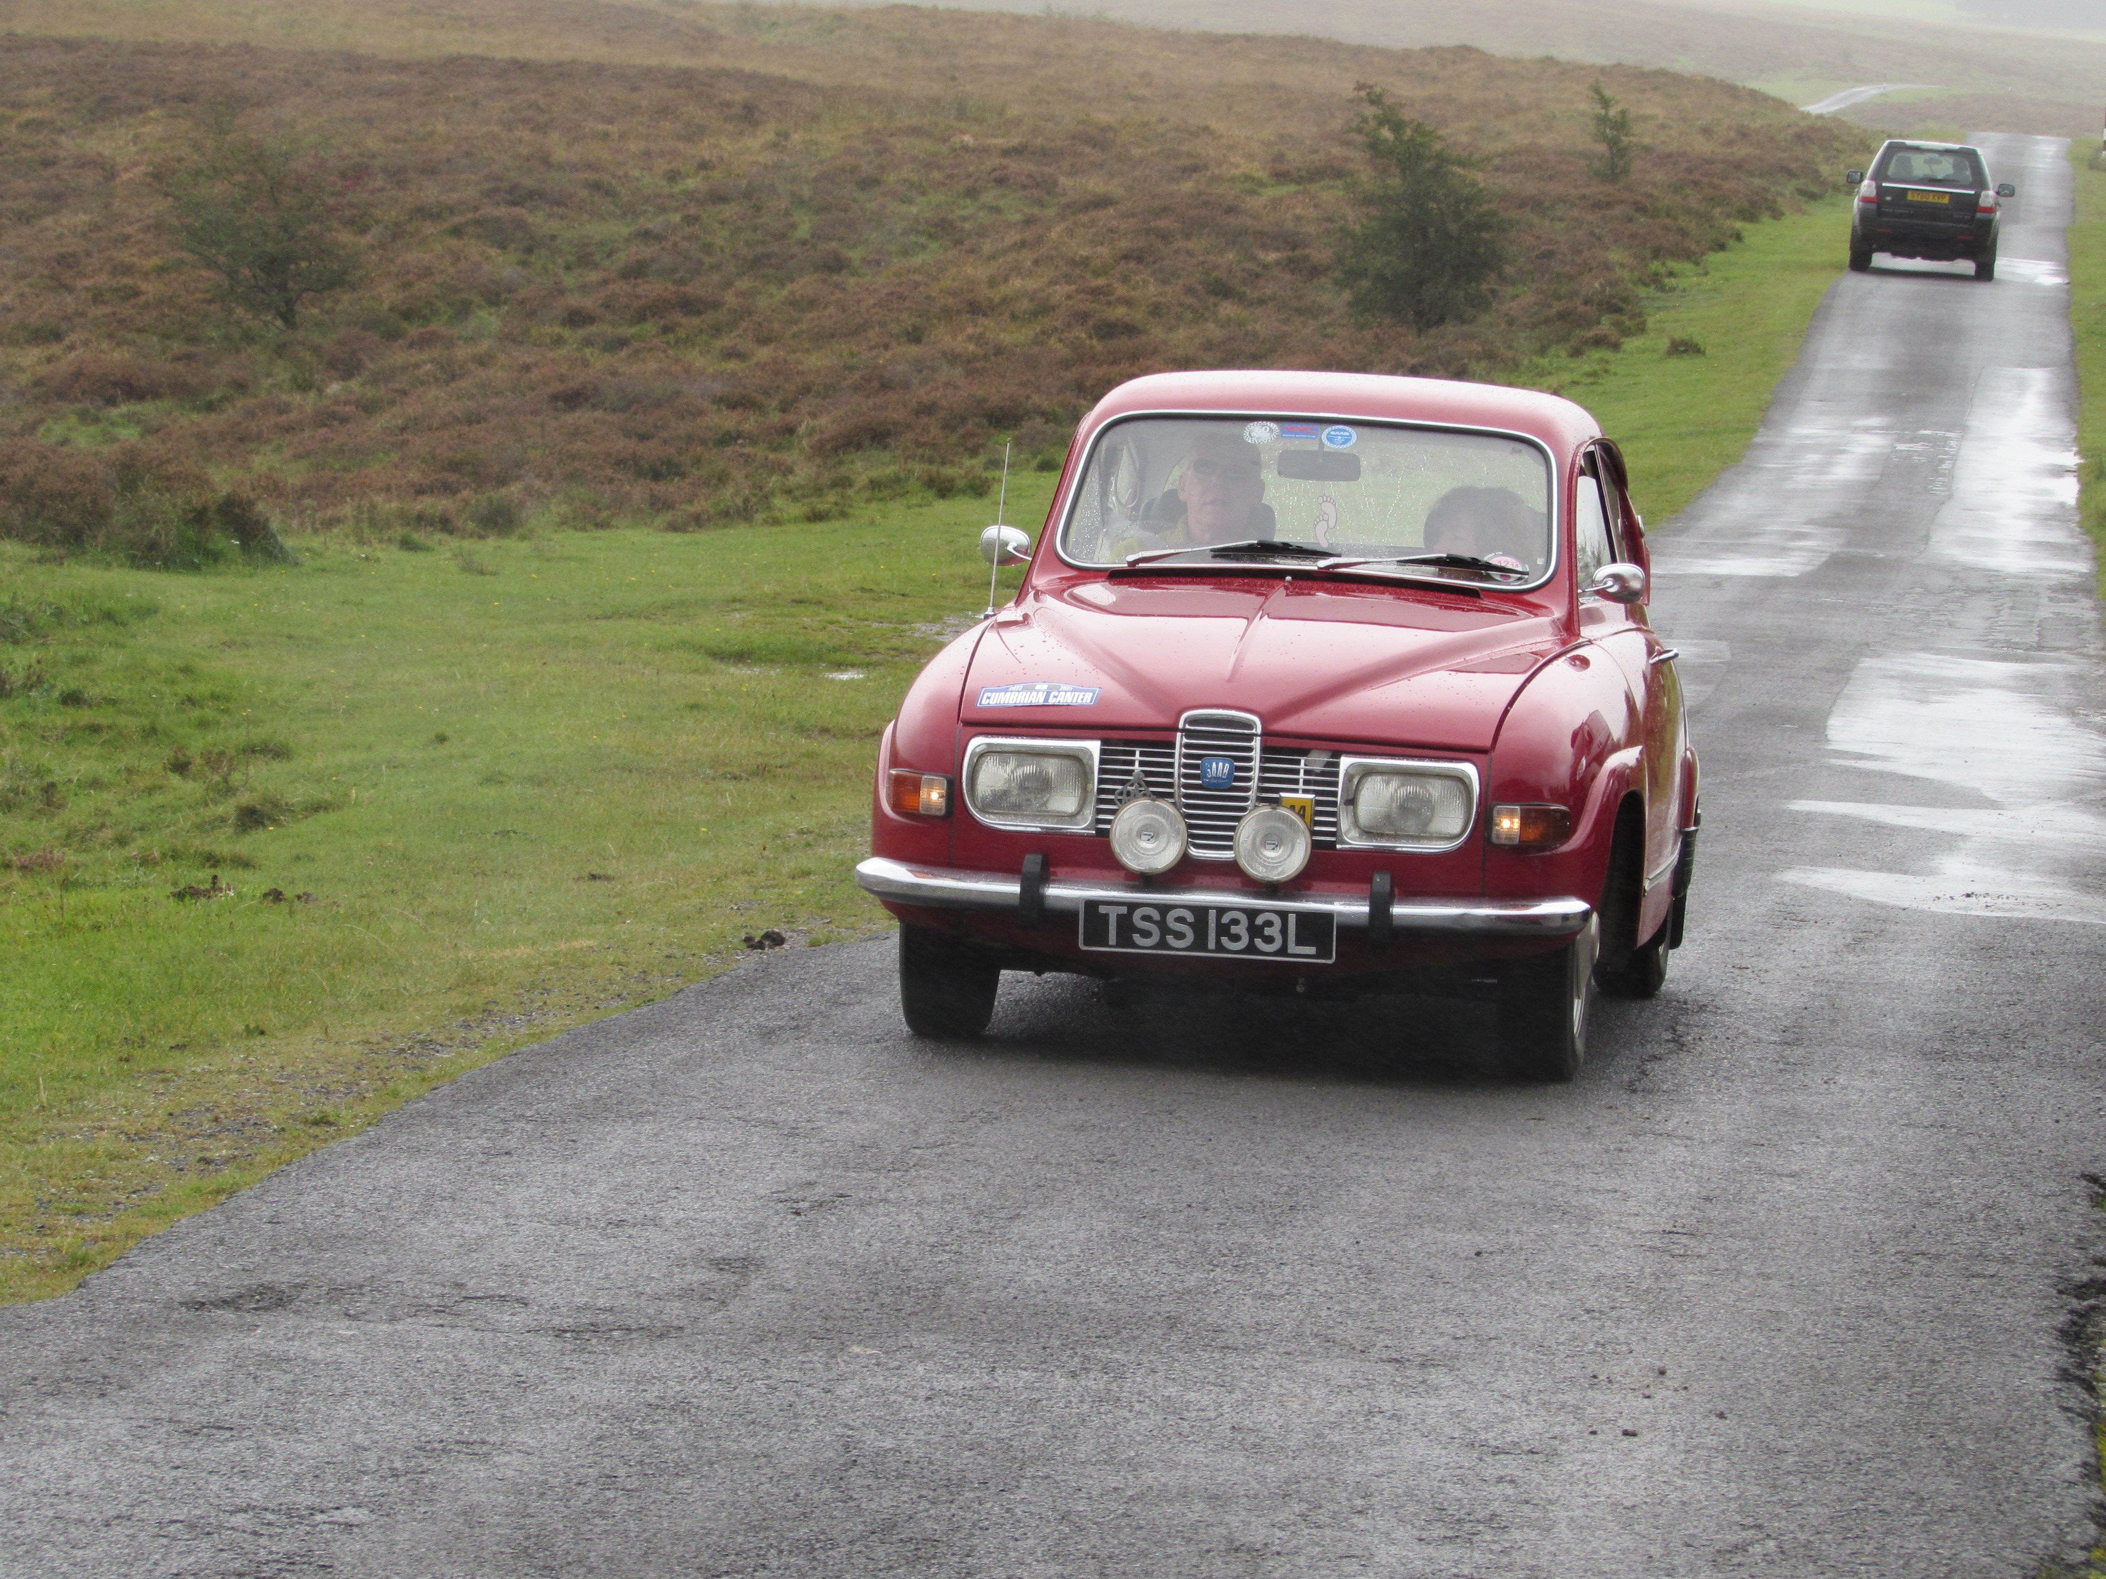

I have pleasure in inviting you to take part in the Cumbrian Canter. It will be a one day Tour to be held on Sunday 22nd September 2024. This Touring Assembly is authorised by Motorsport UK with an Organising Permit/ Certificate of Exemption.

The Cumbrian Canter will start from Basecamp North West, Cocklakes House, Troutbeck which is located off the A66 west of Penrith (Map 90 Ref 275407) and is open to members of Wigton Motor Club and all other enthusiasts driving historic, classic and other fine and sporting cars of any age. A list of starters and start times will be sent out with final instructions during the week prior.

We start our day with bacon or sausage rolls and coffee
Our route this year is 115 miles and will head off to the east and north to Dalston, before heading west and south to the finish at Basecamp. Tickets will be provided for breakfast and the coffee stops, which are included in the event entry fee.

This year there are stops at The Village Bakery in Melmerby and Bowness Hall Farm in Bowness On Solway

The route will be defined by a simple road book with tulip diagrams, directions and distances. If you or your passenger are first timers please feel free to call us and ask us for help and instruction on ‘tulips’ and anything else that may not be clear. There will be no trickery or obscure clues.

The entry fee for Wigton Motor Club members will be £60 per car and for non members £65. Included are bacon rolls and tea/coffee at the start and coffee at Melmeby and Bowness On Solway

The road book instructions, meal tickets, self adhesive plates and a commemorative award will be distributed at signing on in the cafe at the start. The maximum number of entries will be 40 and the entry list closes on 8th September 2024.

Payment is preferably by cheque with entry but bank transfer is acceptable to :-
Wigton Motor Club, Cumberland B Soc, sort code 16-52-21 A/c no 54162124. Please identify your payment with Cumbrian Canter and your name.

Ensure your car insurance covers you for the Touring Assembly which is a non timed, non competitive event run entirely on public roads.We look forward to seeing you and promise as ever an interesting route on scenic driving roads.

Chris Leece
Tel.01768 867576 (after 6pm)
e-mail chris_1lowtherview@yahoo.co.uk

Rec. | Ack.
Wigton Motor Club
Cumbria Canter
Sunday 22 September 2024
ENTRY FORM

Driver: Club M/ship no.
Address:
Post Code: | Telephone:
Navigator:
Address:
Post Code: Telephone:
Driver E-Mail ‘PLEASE PRINT’ | Nav. E-mail. ‘PLEASE PRINT’
Car make: | Model:
Year: | Capacity:
Registration: | Colour:

Entry fee Wigton MC Member £60 | £
Entry fee for non club member £65 | £
Extra meal package for third or fourth crew member if required - £12 per person | £
Total enclosed | £

Entry fees include coffee and bacon rolls at the start
Please make cheques payable to Wigton Motor Club Ltd and post your entry to:-
J C Leece, 1 Lowther View, Clifton, Penrith, Cumbria, CA10 2EB.
Alternatively Payment may be made by Bank transfer to Wigton Motor Club. Cumberland Sort code 16-52-21 account number 54162124 please identify your payment with the Cumbrian Canter and your name.

