Wigton Motor Club
John Peel Meander
Wednesday 7rd May 2025

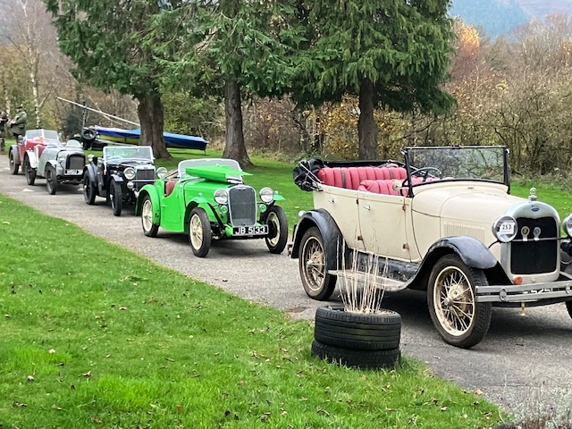

Details andEntry Form

Wigton Motor Club Ltd
John Peel Meander
Wednesday 7th May 2025

We have pleasure in inviting you to take part in our third Meander to be held on Wednesday 7th May 2025. This Touring Assembly is authorised by Motorsport UK with an Organising Permit Certificate of Exemption number . .

The event welcomes anyone in cars from the pre World War Two era although similar cars up to the early 1950s will be most acceptable. We warmly invite those who are part of The Oily Fingernails Group to join us.

The Meander will be approximately 45 miles long and will be run at a very sedate pace with simple route instructions and no formal timing. It is simply an opportunity to exercise your cars on quiet, non challenging Cumbrian roads in the company of fellow enthusiasts. We will start at the Motor House at Moota on the A595 and finish at Base Camp, Cocklakes on the A66 one mile east of Troutbeck, a venue which has proved ideal in the past. A list of entries with start times will be sent out by e-mail with final instructions during the week prior. We start our day with coffee and biscuits at the Motor House from 10.30am and for those requiring something more substantial The Moota Coffee Shop is next door. First car departs at 11.30am.

The route will be defined by a simple road book with tulip diagrams, directions and distances and the entry fee for Wigton Motor Club members will remain unchanged at £25 per car and for non Wigton MC members £30. Included are coffee and biscuits at the start. The road book instructions and self adhesive plates will be distributed at signing on in the Motor House at the start. Food and refreshments will be available at the finish at entrants cost.

It is entrants responsibility to ensure your car insurance covers you for the Touring Assembly which is a non timed, non competitive event run entirely on public roads.
Payment can be made either by bank transfer to Wigton Motor Club A/c at Cumberland BS sort Code 16-52-21 account number 54162124 or by Cheque made out to Wigton Motor Club.
All entry forms to Ron Palmer, Manor Croft, Moorhouse, Carlisle CA5 6EL.

We look forward to seeing a good turn out of interesting cars and hopefully good weather.

All enquiries to :-
Ron and Christine Palmer
ronpalmer777@hotmail.com
01228 575153

Wigton Motor Club
Coronation Meander May 7th 2025
ENTRY FORM

Driver:
Club M/ship no.
Address:
Post Code: | Telephone:
Passenger
Address:
Post Code: Telephone:
Driver E-Mail ‘PLEASE PRINT’

Car make: | Model:
Year: | Registration no.

ENTRY FEES:
Entry fee Wigton MC Member £25 | £
Entry fee for non club member £30 | £
 | £
Total enclosed | £

Entry by cheque payable to Wigton Motor Club Ltd or by bank transfer to Cumberland Blg Soc. sort code 16-52-21 account number 54162124.
Post or email your entry to:- Ron Palmer, Manor Croft, Moorhouse, Carlisle, CA5 6EL

